Project Proposal – Concierge Lifestyle
Name: Bilal Ali
Roll No: 4
Class: TYBSc(CS)

Title
The Rise of Concierge Lifestyle: Personalized Living in a Fast-Paced World
A study and digital concept proposal highlighting the increasing demand for concierge services in today’s high-paced, time-starved society.

Introduction
In an era of increasing professional obligations and fast-moving urban life, the concierge lifestyle has emerged as a personalized solution offering convenience, luxury, and efficiency. This project explores how digital concierge services are transforming the way individuals manage their day-to-day responsibilities, improving life quality by offering tailored support for personal, social, and professional tasks.

Objectives
• To explore the concept and components of a concierge lifestyle
• To identify the target user base and evaluate user needs
• To highlight digital trends in concierge service platforms
• To develop a conceptual or prototype solution of a digital concierge system
• To evaluate benefits and drawbacks of concierge-based living

Scope
This project encompasses a broad range of lifestyle services that can be managed by a personal concierge, such as travel planning, event management, grocery or gift delivery, appointment scheduling, home services, and exclusive luxury access. The scope also extends to digital service delivery platforms and mobile apps that streamline concierge experiences. Though primarily targeted toward HNWIs, this model can be adapted for upper-middle-class professionals through scalable tech.

Methodology
The project will follow a qualitative research-based approach with optional app prototyping. The methodology includes:
• Literature Review – Studying existing concierge platforms
• Surveys/Interviews – Understanding user needs and market gaps
• System Design – Outlining essential features for a digital platform
• Wireframing – Using Figma or similar tools to build basic UI
• Final Report – Compiling findings and suggestions for real-world applications

Tools and Technologies
- React Native – For building the cross-platform mobile application with native performance
- Expo – For development environment, build tools, and native API access
- Expo Router – For navigation between screens and routes in the app
- TypeScript – For type-safe code and better developer experience
- Supabase – For authentication, database (PostgreSQL), real-time functionality, and storage
- Tailwind CSS – For styling components with utility-first approach
- React Context API – For state management (AuthContext)
- React Hooks – For functional component logic (useEffect, useState, custom hooks)
- Git – For version control and collaboration
- Vite – For fast development server and bundling
- Node.js – For running the development server and managing dependencies
- npm / yarn – For package management and dependency installation
- XAMPP – For local development server hosting (as indicated by workspace path)
- Visual Studio Code – For code editing and development (inferred from IDE context)
- Qoder IDE – For AI-assisted coding and development workflow

Timeline
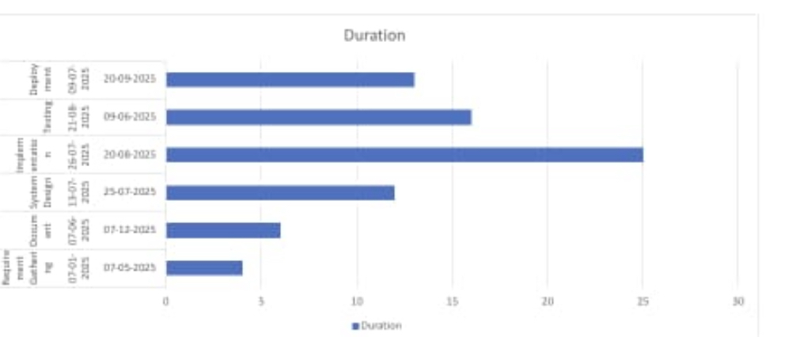

Resources
• Internet-enabled device (smartphone or laptop)
• Online tools (Figma, Canva, Notion, Trello)
• Access to research papers and lifestyle magazines
• User feedback through forms or informal interviews
• Guidance from project mentor/instructor

Expected Outcomes
• A detailed report on the growing relevance of concierge lifestyles
• A simple working prototype or conceptual model of a digital concierge app
• A well-designed UI wireframe demonstrating features and flow
• Improved understanding of market trends in luxury/personalized services
• Potential real-world applications in mobile apps or service startups

References
• Harvard Business Review – Time Management Studies
• Medium Blogs – Concierge Startups and Trends
• TechCrunch – Articles on Digital Lifestyle Apps
• App Store Listings – UrbanClap, TaskRabbit, Bolt Concierge
• ResearchGate – Studies on Lifestyle Personalization

